

SYMBIOSIS INTERNATIONAL (DEEMED UNIVERSITY)
(Established under section 3 of the UGC Act 1956)
Re-accredited by NAAC with “A” Grade

Name of the Student: Sneha Sah PRN: 25070122189
Semester: 3 Year: AY 25-29

ASSIGNMENT No: 2

TITLE: Develop a Java application demonstrating the use of default, parameterized, and copy constructors for object initialization and data management.
Problem Statement: Develop a Java application demonstrating the use of default, parameterized, and copy constructors for object initialization and data management.

Source code:

1.Default Constructor
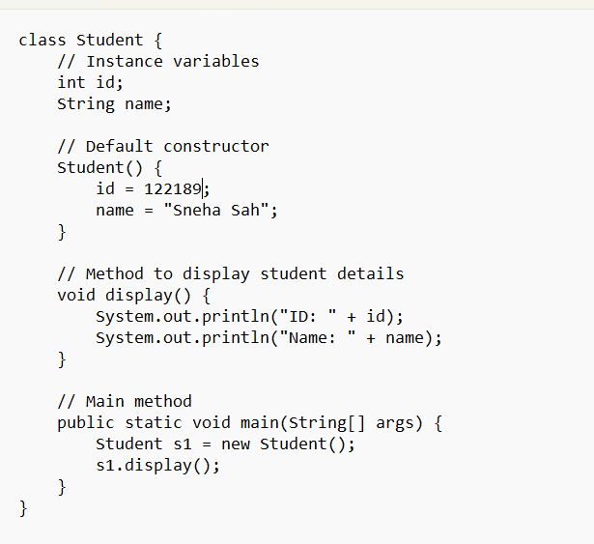
Output:
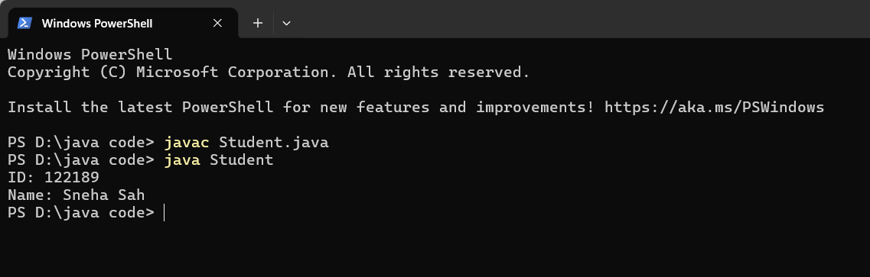

2. Parameterized Constuctor
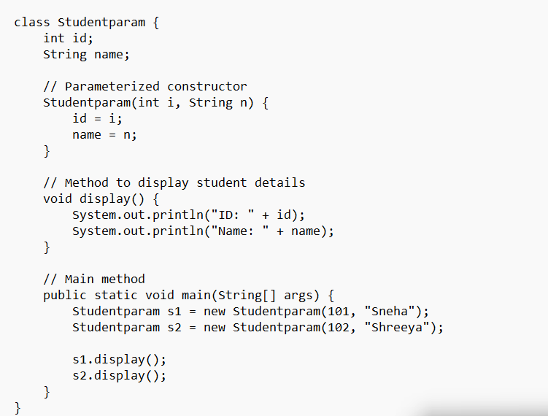

Output:
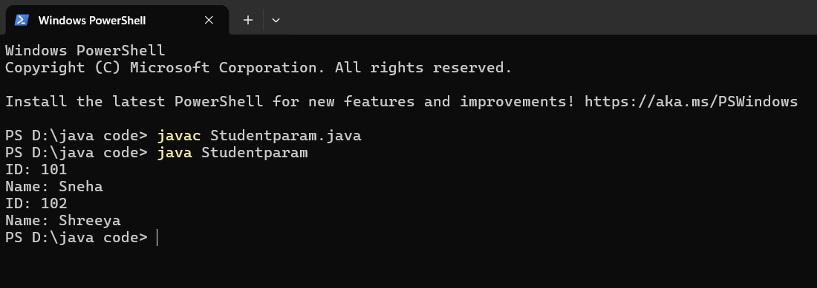

Exercise:
- Create a Student class using default and parameterized constructors to initialize student name and roll number.
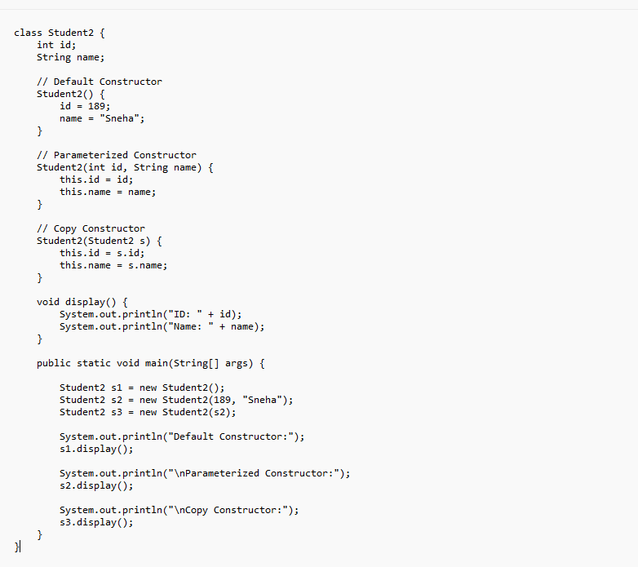
Output:
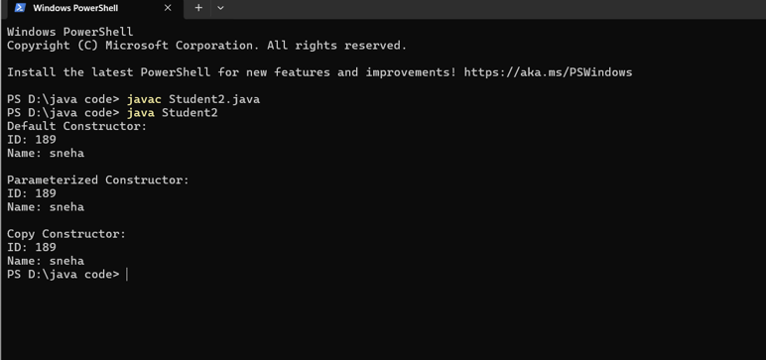

2.Develop a Mobile Phone Inventory System using different constructors to initialize mobile details and create duplicate object records.

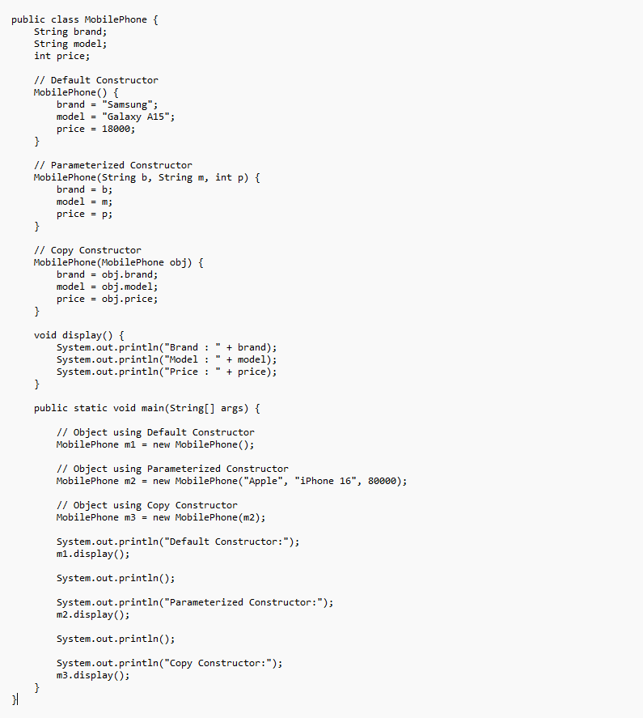
Source code:

Output:
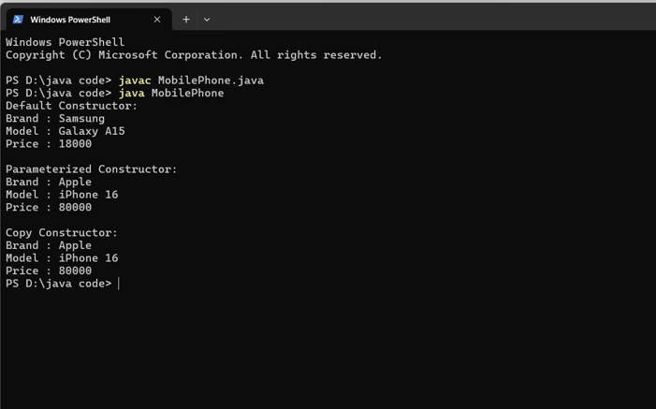

Conclusion
This Java application successfully demonstrates the use of default, parameterized, and copy constructors for object initialization and data management. The default constructor initializes objects with predefined values, the parameterized constructor allows user-defined initialization, and the copy constructor creates a new object by copying the values of an existing object. This program improves code reusability, simplifies object creation, and helps in efficient data management. Overall, the assignment provides a clear understanding of how different types of constructors are used in Java to initialize objects in different ways.

